**Wine Quality Prediction using 3 models.**

import pandas as pd  
import numpy as np  
import matplotlib.pyplot as plt  
import seaborn as sns  
from sklearn.model_selection import train_test_split, GridSearchCV  
from sklearn.linear_model import LinearRegression  
from sklearn.preprocessing import StandardScaler, LabelEncoder  
from sklearn.metrics import mean_absolute_error, mean_squared_error, r2_score  
from xgboost import XGBRegressor  
import lightgbm as lgb  
  
  
df = pd.read_csv(r"C:\Users\Administrator\Downloads\Wine_Quality_Data.csv")  
  
  
if 'color' in df.columns:  
 df['color'] = LabelEncoder().fit_transform(df['color'])  
  
  
X = df.drop(columns=['quality'])  
y = df['quality']  
  
  
scaler = StandardScaler()  
X_scaled = scaler.fit_transform(X)  
  
  
X_train, X_test, y_train, y_test = train_test_split(X_scaled, y, test_size=0.2, random_state=42)  
  
  
lr_model = LinearRegression()  
lr_model.fit(X_train, y_train)  
y_pred_lr = lr_model.predict(X_test)  
  
  
xgb_model = XGBRegressor(objective='reg:squarederror', random_state=42)  
xgb_param_grid = {  
 'learning_rate': [0.01, 0.1, 0.2],  
 'max_depth': [3, 5, 7],  
 'n_estimators': [50, 100, 200]  
}  
xgb_grid_search = GridSearchCV(estimator=xgb_model, param_grid=xgb_param_grid, cv=5, n_jobs=-1, scoring='neg_mean_squared_error')  
xgb_grid_search.fit(X_train, y_train)  
best_xgb_model = xgb_grid_search.best_estimator_  
y_pred_xgb = best_xgb_model.predict(X_test)  
  
  
lgb_model = lgb.LGBMRegressor(random_state=42)  
lgb_param_grid = {  
 'learning_rate': [0.01, 0.1, 0.2],  
 'max_depth': [3, 5, 7],  
 'n_estimators': [50, 100, 200]  
}  
lgb_grid_search = GridSearchCV(estimator=lgb_model, param_grid=lgb_param_grid, cv=5, n_jobs=-1, scoring='neg_mean_squared_error')  
lgb_grid_search.fit(X_train, y_train)  
best_lgb_model = lgb_grid_search.best_estimator_  
y_pred_lgb = best_lgb_model.predict(X_test)  
  
  
def evaluate_model(name, y_true, y_pred):  
 print(f"\n{name} Evaluation:")  
 print("MAE:", mean_absolute_error(y_true, y_pred))  
 print("MSE:", mean_squared_error(y_true, y_pred))  
 print("R² Score:", r2_score(y_true, y_pred))  
  
  
evaluate_model("Linear Regression", y_test, y_pred_lr)  
evaluate_model("XGBoost Regressor", y_test, y_pred_xgb)  
evaluate_model("LightGBM Regressor", y_test, y_pred_lgb)  
  
  
plt.figure(figsize=(18, 6))  
  
plt.subplot(1, 3, 1)  
sns.scatterplot(x=y_test, y=y_pred_lr)  
plt.plot([y.min(), y.max()], [y.min(), y.max()], 'r--')  
plt.title("Linear Regression")  
plt.xlabel("Actual Quality")  
plt.ylabel("Predicted Quality")  
  
plt.subplot(1, 3, 2)  
sns.scatterplot(x=y_test, y=y_pred_xgb)  
plt.plot([y.min(), y.max()], [y.min(), y.max()], 'r--')  
plt.title("XGBoost Regressor")  
plt.xlabel("Actual Quality")  
plt.ylabel("Predicted Quality")  
  
plt.subplot(1, 3, 3)  
sns.scatterplot(x=y_test, y=y_pred_lgb)  
plt.plot([y.min(), y.max()], [y.min(), y.max()], 'r--')  
plt.title("LightGBM Regressor")  
plt.xlabel("Actual Quality")  
plt.ylabel("Predicted Quality")  
  
plt.tight_layout()  
plt.show()  
  
  
plt.figure(figsize=(10,6))  
xgb_importance = pd.Series(best_xgb_model.feature_importances_, index=X.columns)  
xgb_importance.sort_values().plot(kind='barh', color='green')  
plt.title("XGBoost Feature Importance")  
plt.grid(True)  
plt.tight_layout()  
plt.show()  
  
  
plt.figure(figsize=(10,6))  
lgb_importance = pd.Series(best_lgb_model.feature_importances_, index=X.columns)  
lgb_importance.sort_values().plot(kind='barh', color='blue')  
plt.title("LightGBM Feature Importance")  
plt.grid(True)  
plt.tight_layout()  
plt.show()

**Output:**  
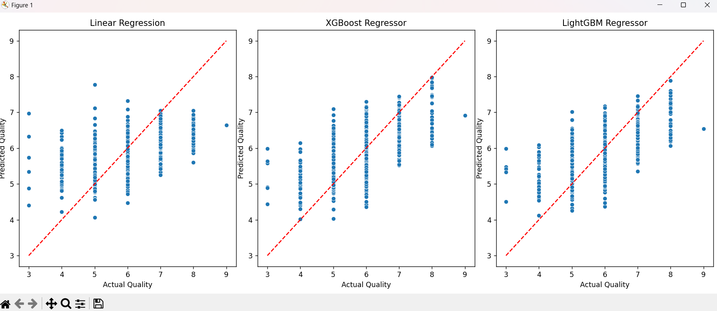

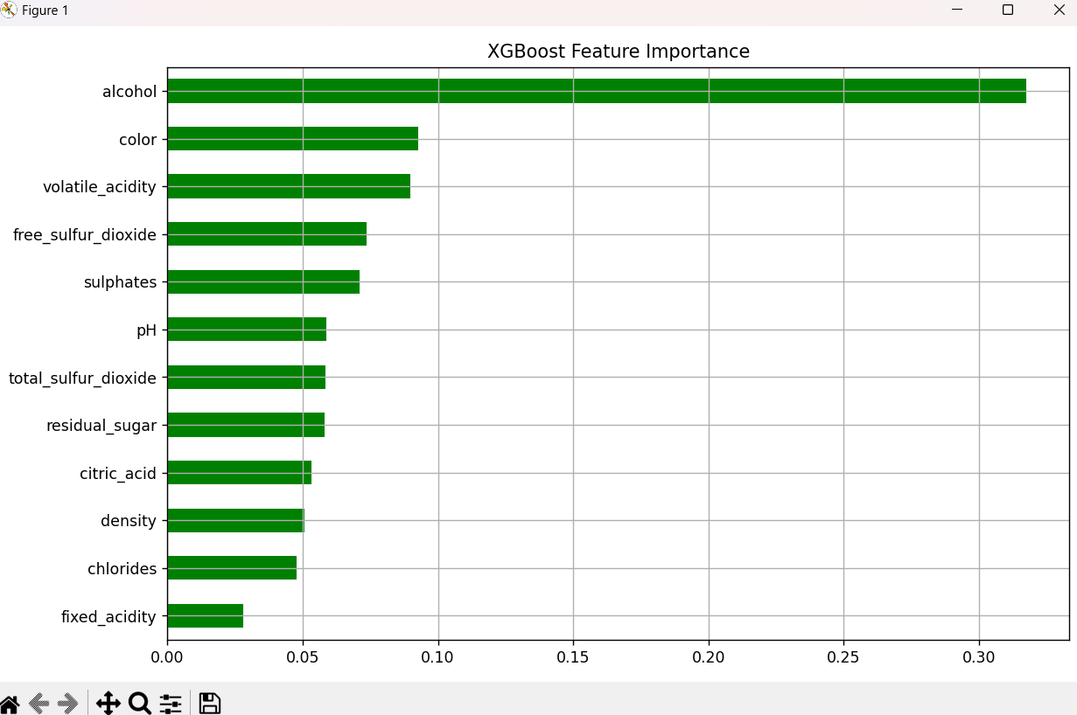

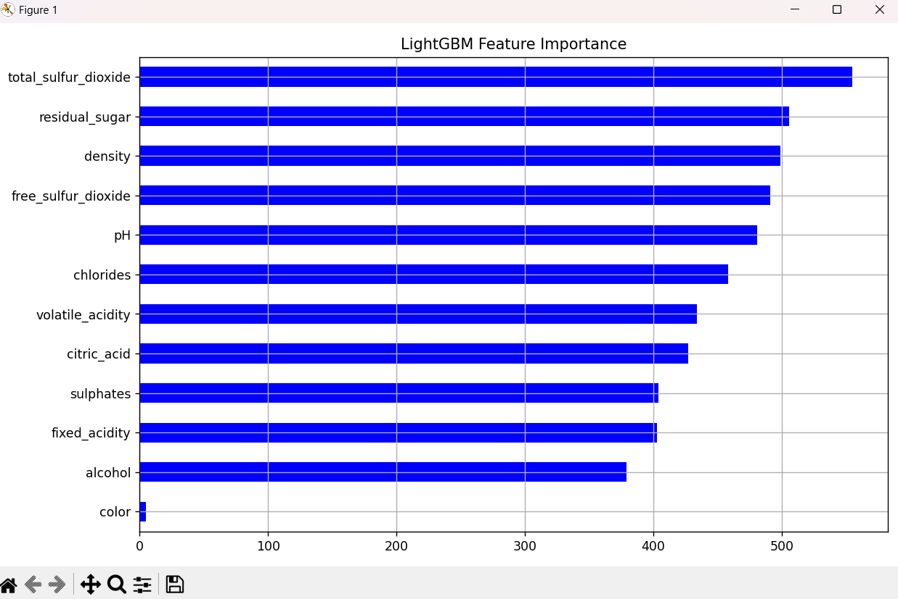

**Eval results, final prediction output:**

